**United College of Engineering and Management**

**Naini, Allahabad**

Project Synopsis

on

**You Heal We Help**

Under the guidance

of

Mr.Jeetesh Srivastava

Submitted by:

Student Roll No: 1834210065 Name: Piyush Mehrotra

Student Roll No: 1834210084 Name:Shivam Singh

Student Roll No: 1834210087 Name: Shreya

Student Roll No: 1834210090 Name: ShubhangiSoni

Student Roll No: 1834210110 Name: Vivek Tripathi

**Department of Computer Science, UCEM**

**GUIDELINES FOR THE PREPARATION AND SUBMISSION**

**OF SYNOPSIS OF B.TECH MAJOR PROJECT WORK**

This document provides a set of guidelines and format of the synopsis that must be submitted after having chosen the application area and topic of the dissertation work in B.Tech Program. The students are advised to strictly follow the guidelines and format while giving a strong emphasis of the goals of the dissertation to be achieved. The guidelines are as follows:

1. The student shall write everything in his/her own words.
2. Use MSWord, 12 Point Times New Roman Font, Single Column, use laser printer and print it on A4 size paper.
3. Approximately one-inch margin on each side of the page should be maintained.
4. The Synopsis shall be typed on one side of the page only.
5. In the synopsis, the title page [Refer sample sheet] should be given first.

**Note:**

* **Synopsis must be approved by your Guide before the Internal Presentation.**
* **Synopsis should not be more than 8-12 pages.**
* **Each Group is required to submit a hard copy of approved synopsis of major Project on the day of Presentation.**

**Format for Project Synopsis Report**

* Introduction (About the project)
* Problem Statement
* Proposed Solution (consists of details/hierarchal chart etc.)/Model
* Scope of a project (coverage of a proposed project)
* DFD (Data Flow Diagrams)
  + Zero level DFD
  + Level-1 Physical DFD
* ERD (Entity Relationship Diagram)
* Proposed Technology/Platform
  + Frontend
  + Backend
* Minimum Hardware/Software requirements:
* Module Description
  + Module name
  + Description
  + Required Input
  + Expected output
* Future scope
* References

1. **Introduction**

Are you searching for a help, for you or your relative’s faster recovery or for performing rituals if someone died? Do you know which hospitals are having poison cell? Do you want to know more about some bigger diseases from well-known doctors? Don’t have money, for the treatment of your loved one and need help? Don’t worry, this is the reason why we are here:

**You Heal We Help**

Our project’s main aim is to analyze data and help the needy by recommending the best facilities of hospitals, doctors, specialist near you.

We also help fresher/junior doctors to learn more from experienced doctors and users to get health awareness from them by organizing seminars. We bridge a gap between the poor patients by connecting them directly to the NGOs for instant fund raising.

When anyone is died, and you need help for doing all the rituals regarding him and no one is there to help, don’t worry, we provide all sorts of ritualpractices as taking death body from your home to ghat as well as providing the death certificate too.

1. **Problem Statement**

Hospital management system is being used everywhere but most of themdeals with the doctor’s availability and their appointments, medicine available or not. Some more problems are:

* People facing difficulties in finding poison cell, beds, oxygen, ventilators, blood and plasma for their near and dear ones.
* Awareness of diseases and symptoms is essential for screening and early detection.
* Specially the problems are faced in times of pandemic or any natural disasters it becomes onerous to cremate the body of so many people.
* Need for instant money for treatment is also a challenge for the poor ones or middle class people.
* Existing Scenario:
* The existing systemsare highly manual and all work is done traditionally or if they are online then they either provide information regarding doctor’s availability or names of hospitals, or medicine delivery.
* One has to go to different hospitals to find whether it has poison cell or not.
* One has to find out whether the treatment for the disease for which they are looking is available in that hospital or not.
* After that, one has to collect information about charges and everything else there.
* People in need for money go to social media and post for fund raising which takes a lot of time.
* Some new diseases are still unknow for small area or small doctors, because of which it takes much time for them to diagnose.
* Drawbacks:
* Currently, we don't have any website for providing all information at one place.
* Manually searching for particular facilities in hospital with good rating is a very crucial and challenging task. Hence, it’satime-consuming task and in case of emergency it can cause serious damage.
* In general, it is very expensive because usershas less knowledge about hospitals and cost for treatment.
* Finding a hospital is a problem for those, who live alone or for senior citizens?
* There are some diseases whose doctors are not easily found, finding hospitals for those diseases is a big challenge (like poison cell, etc.).

1. **Proposed Solution**

**You Heal We Help** provides you best quick healing options near you We are helping hands for our users for their quick recovery. Some solutions we provide are:

* The main aim of this site is to reduce death rates, by providing faster search results of best rated doctors, facilities and hospitals regarding specific problem and its solution available near them.
* It will also organize different seminars for fresher/junior doctors to interact with experienced doctors.A health awareness program for public user about new diseases, its causes and solutions.
* As the services and interactions are improved in all possible ways, everything is being planned with greater precision.
* It saves the time of all the system users and provides them with up-to-date information.
* It also helps to connect with NGOs for instant fund raising for the needy.
* In pandemic situations or disasters or for upcoming generations, people need help for the cremation of their loved ones because of not known about rituals or pandemic doesn’t allow people to help, so in these situations we provide a helping hand for such people.

1. **Scope of the Project**

* The system will be used by any connected hospitals and its doctors, NGOs, or any user who want to get any information about treatment, or fund required for it or details related for doing the cremation of a person.
* We try to make it easily available to user so that they cannot wander everywhere.
* The new thing which we added is the cremation facility as it is not available anywhere online. The current cremation system is totally offline and hard for people those are unaware of rituals and we try to make it online to help them and we think it will very helpful for everyone.

1. **Data Flow Diagram(DFD)**

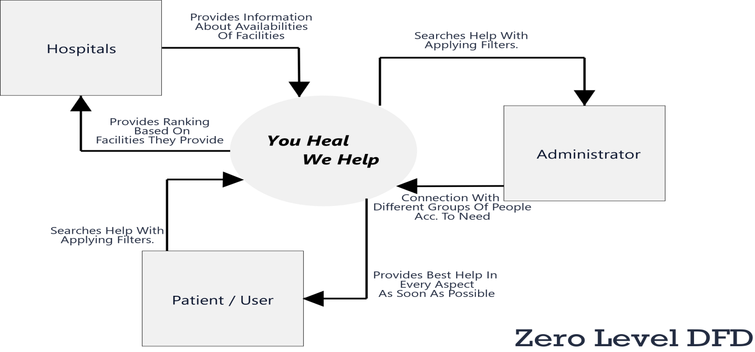

**Level 1 DFDs for all modules:**

1. **Search Module:**

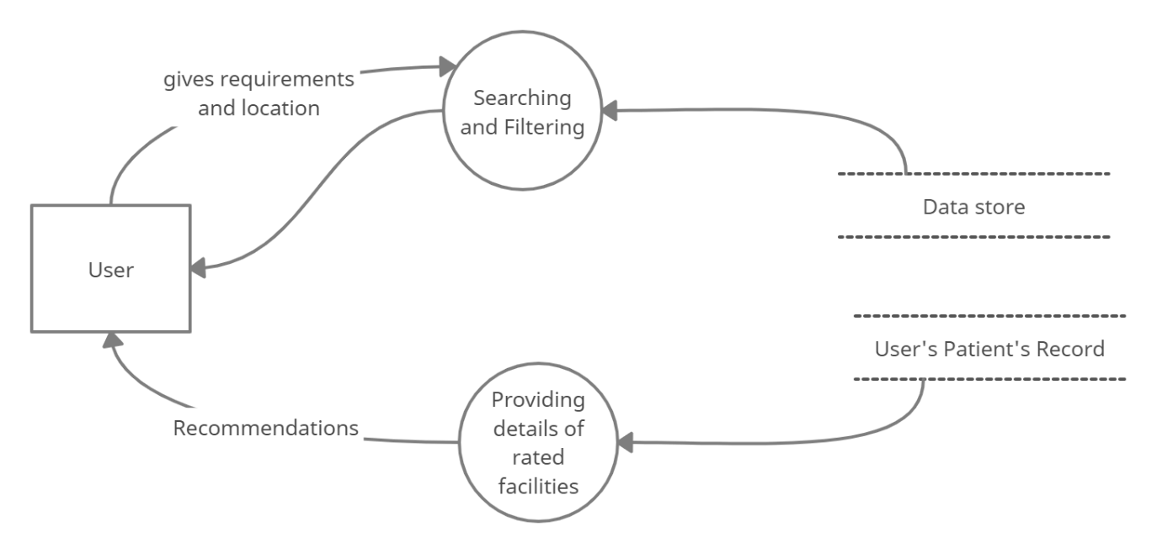

1. **Hospital Module:**

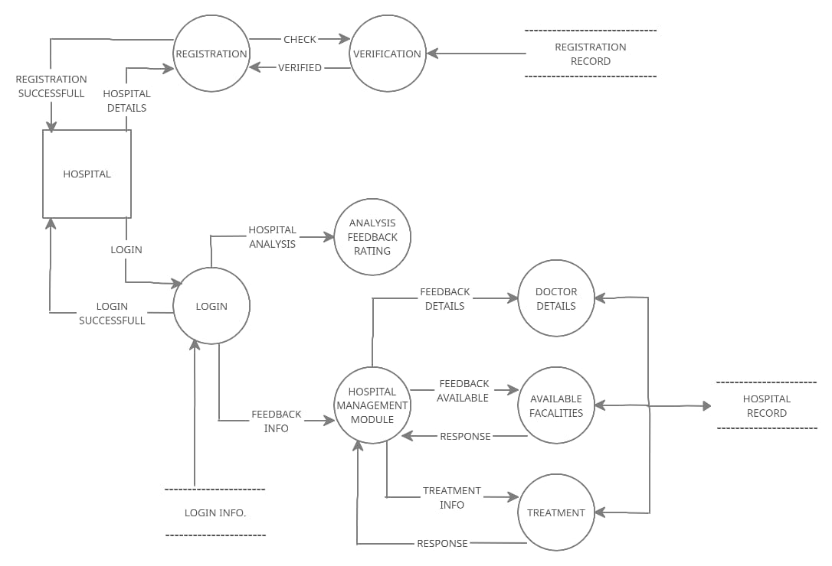

1. **User Module:**

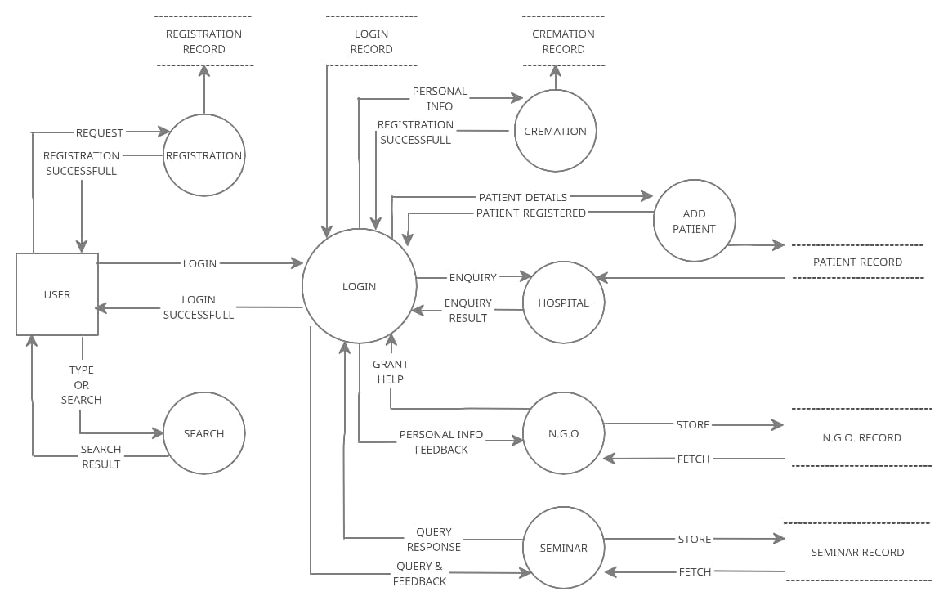

1. **Cremation:**

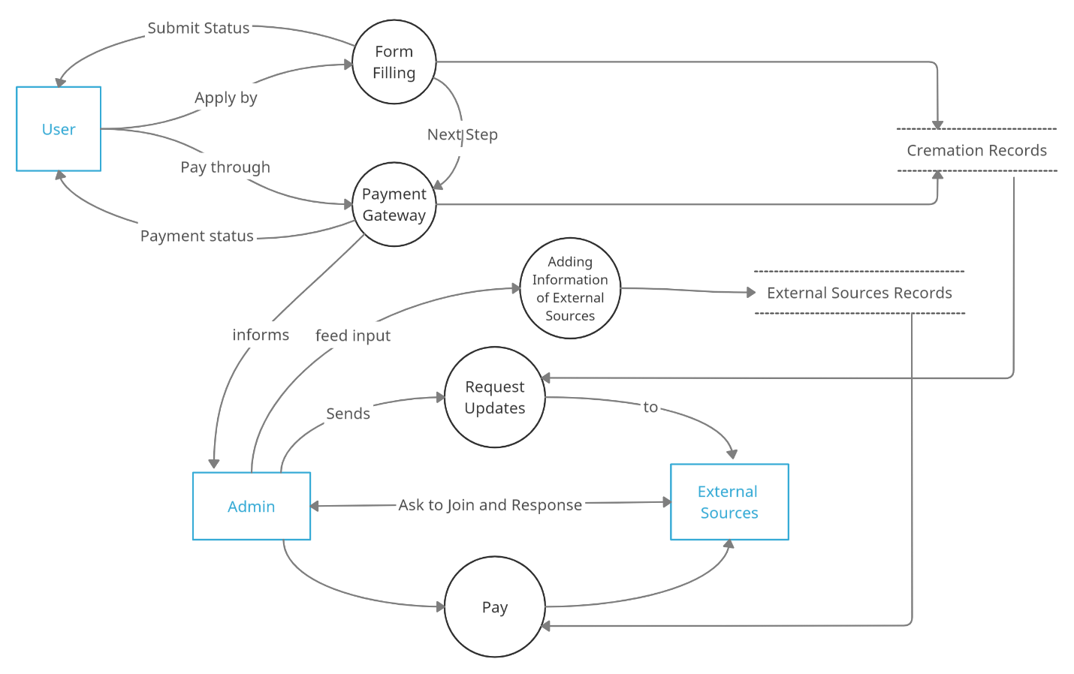

1. **Health Seminar:**

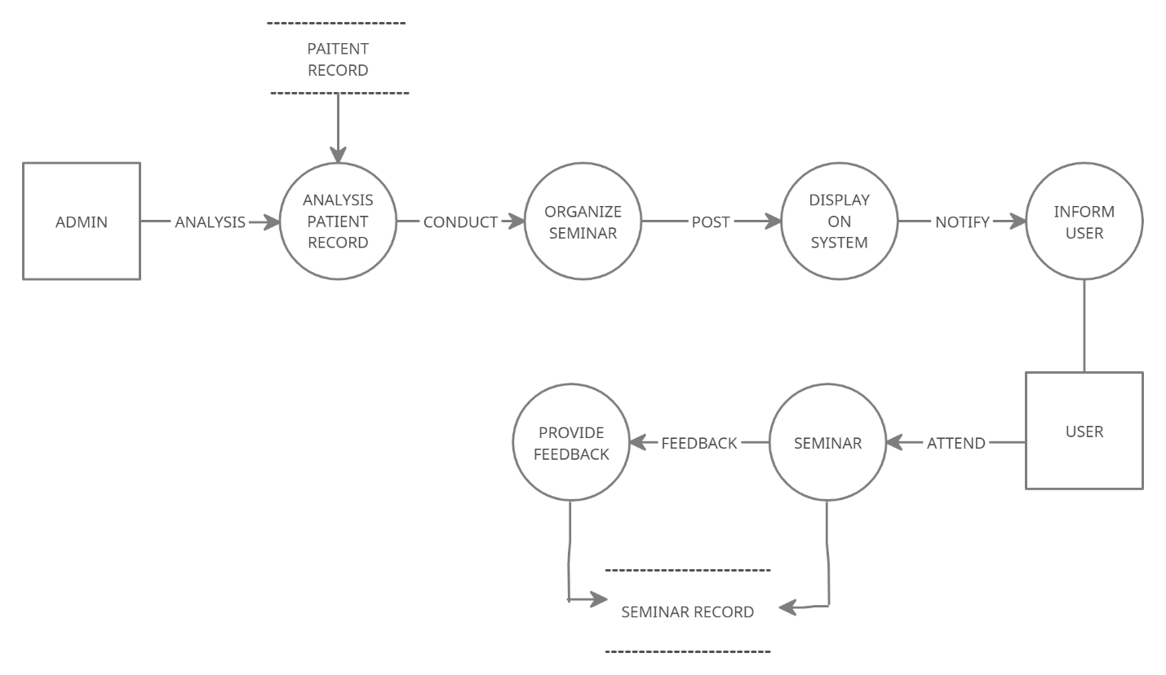

1. **NGO:**

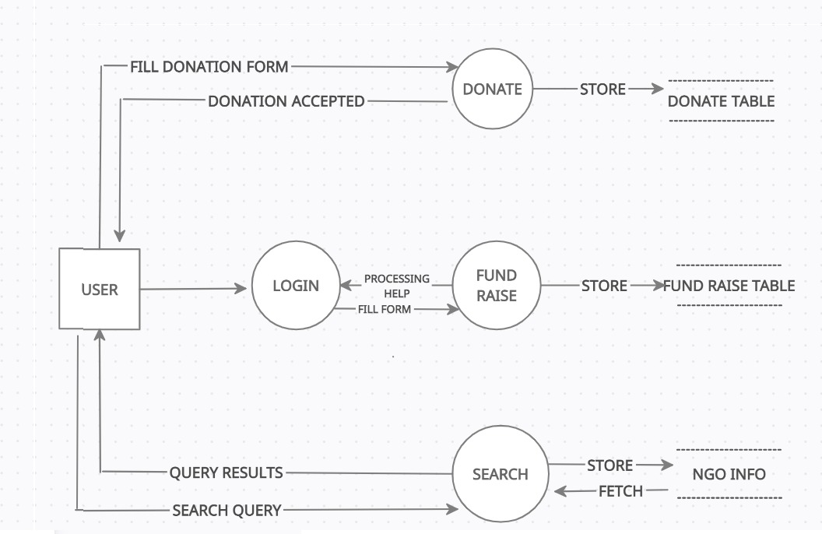

1. **Entity Relationship Diagram(ERD):**

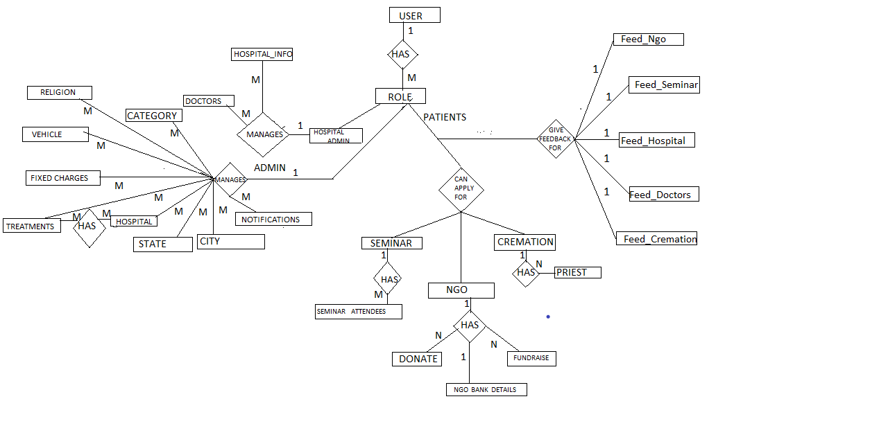



**8.Tables:**

Table_Name : Hospital

|  |  |
| --- | --- |
| Attributes | Datatypes |
| name | CharField(max_length=255) |
| phone_no | PositiveBigIntegerField() |
| license | FileField(upload_to=’ ‘) |
| image | ImageField(upload_to=’ ‘) |
| address | CharField(max_length=255) |
| city | ForeignKey(tablename:City) |
| pin | PositiveIntegerField() |
| is_verified | BooleanField(default=False) |

Table_Name : HopitalInfo

|  |  |
| --- | --- |
| Attributes | Datatypes |
| hospital | OneToOneField(hospital) |
| total_beds | PositiveIntegerField() |
| remaining_beds | PositiveIntegerField() |
| poison_cell | BooleanField(default = false) |
| oxygen | BooleanField(default = true) |

Table_Name: Treatment

|  |  |
| --- | --- |
| Attributes | Datatypes |
| hospital | ForeignKey(tablename:Hospital) |
| diseases | TextField() |
| name | Charfield(max_length=255) |
| description | TextFields() |
| cost | DecimalFields() |

Table_Name : HospitalAdmin

|  |  |
| --- | --- |
| Attributes | Datatypes |
| user | ForeignKey(tablename:User) |
| hospital | ForeignKey(tablename:Hospital) |

Table_Name : Doctors

|  |  |
| --- | --- |
| Attributes | Datatypes |
| hospital | ForeignKey(tablename:Hospital) |
| name | CharField(Maxlength=255) |
| email | EmailField() |
| degree | CharField(Maxlength=255) |
| degree_file | FileField(upload_to=’ ‘) |
| phone_no | PositiveBigIntegerField() |
| image | ImageField(upload_to=’ ‘) |
| specialization | ForeignKey(tablename:Category) |

Table_Name : Ngo

|  |  |
| --- | --- |
| Attributes | Datatypes |
| registration_no | CharField(max_length=255, unique=True) |
| name | CharField(max_length=255) |
| purpose | CharField(max_length=255) |
| address | CharField(max_length=255) |
| city | ForeignKey(tablename :City) |
| description | TextField() |
| phone_no | PositiveBigIntegerField() |
| image | ImageField(upload_to='') |
| email | EmailField() |

Table_Name : NgoBankDetails

|  |  |
| --- | --- |
| Attributes | Datatypes |
| ngo | OneToOneField(Ngo) |
| account_no | CharField(max_length=255) |
| ifsc_code | CharField(max_length=255) |
| name | CharField(max_length=255) |
| bank_name | CharField(max_length=255) |

Table_Name : FundRaisE

|  |  |
| --- | --- |
| Attributes | Datatypes |
| user | ForeignKey(tablename :User) |
| ngo | ForeignKey(tablename :Ngo) |
| patient_name | CharField(max_length=255) |
| prescription | ImageField(upload_to='') |
| patient_address | CharField(max_length=255) |
| reason | TextField() |
| amount | DecimalField() |

Table_Name : Donate

|  |  |
| --- | --- |
| Attributes | Datatypes |
| ngo | ForeignKey(tablename :Ngo) |
| name | CharField(max_length=255) |
| address | TextField() |
| phone_no | PositiveBigIntegerField() |
| email | EmailField() |
| amount | DecimalField() |

Table_Name : Seminar

|  |  |
| --- | --- |
| Attributes | Datatypes |
| speaker | CharField(max_length=255) |
| title | CharField(max_length=255) |
| description | TextField() |
| date | DateField(auto_now=False) |
| start_at | TimeField() |
| duration | DecimalField() |
| mode | CharField(max_length=10) |
| venue | CharField(max_length=255) |
| cover_image | ImageField(upload_to='seminar') |
| watch_on_url | CharField(max_length=255) |

Table_Name : SeminarAttendees

|  |  |
| --- | --- |
| Attributes | Datatypes |
| name | CharField(max_length=255) |
| age | PositiveIntegerField() |
| mobile_no | PositiveBigIntegerField() |
| email | EmailField |

Table_Name : User

|  |  |
| --- | --- |
| Attributes | Datatypes |
| email | EmailField |
| name | CharField( max_length = 255) |
| mobile_number | CharField( max_length = 255) |
| profile_image | ImageField(upload_to="user_profile") |
| role_assigned | .ForeignKey(tablename:Role) |
| address | CharField(max_length=255) |
| is_verified | .BooleanField(default=False) |
| is_staff | BooleanField(default=False) |
| is_active | BooleanField(default=True) |

Table_Name : Feed_Ngo

|  |  |
| --- | --- |
| Attributes | Datatypes |
| user | ForeignKey(tablename:(User) |
| ngo | ForeignKey(tablename:Cremation) |
| rating | PositiveIntegerField() |
| description | CharField(max_length=255) |
| suggestion | CharField(max_length=255) |

Table_Name : Feed_Seminar

|  |  |
| --- | --- |
| Attributes | Datatypes |
| user | ForeignKey(tablename:(User) |
| seminar | ForeignKey(tablename:Cremation) |
| rating | PositiveIntegerField() |
| description | CharField(max_length=255) |
| suggestion | CharField(max_length=255) |

Table_Name : Feed_Hospital

|  |  |
| --- | --- |
| Attributes | Datatypes |
| user | ForeignKey(tablename:(User) |
| hospital | ForeignKey(tablename:Cremation) |
| rating | PositiveIntegerField() |
| description | CharField(max_length=255) |
| suggestion | CharField(max_length=255) |

Table_Name : Feed_Doctor

|  |  |
| --- | --- |
| Attributes | Datatypes |
| user | ForeignKey(tablename:(User) |
| doctor | ForeignKey(tablename:Cremation) |
| rating | PositiveIntegerField() |
| description | CharField(max_length=255) |
| suggestion | CharField(max_length=255) |

Table_Name : Feed_Cremation

|  |  |
| --- | --- |
| Attributes | Datatypes |
| user | ForeignKey(tablename:(User) |
| cremation | ForeignKey(tablename:Cremation) |
| rating | PositiveIntegerField() |
| description | CharField(max_length=255) |
| suggestion | CharField(max_length=255) |

Table_Name : Notifications

|  |  |
| --- | --- |
| Attributes | Datatypes |
| receiver | ForeignKey(tablename:User) |
| title | CharField(max_length=255) |
| text | CharField(max_length=255) |

Table_Name : FixedCharges

|  |  |
| --- | --- |
| Attributes | Datatypes |
| name | CharField(max_length=255) |
| amount | DecimalField() |

Table_Name : Religion

|  |  |
| --- | --- |
| Attributes | Datatypes |
| name | CharField(max_length=255) |
| amount | DecimalField() |

Table_Name : Vehicle

|  |  |
| --- | --- |
| Attributes | Datatypes |
| city | ForeignKey(tablename:City) |
| vehicle_no | CharField(max_length=255) |
| driver_name | CharField(max_length=255) |
| phone_no | PositiveBigIntegerField() |

Table_Name : Priest

|  |  |
| --- | --- |
| Attributes | Datatypes |
| religion | ForeignKey(tablename:Religion) |
| name | CharField(max_length=255) |
| phone_no | CharField(max_length=255) |
| address | CharField(max_length=255) |
| city | ForeignKey(tablename:City) |

Table_Name : Cremation

|  |  |
| --- | --- |
| Attributes | Datatypes |
| user | ForeignKey(tablename:User) |
| religion | ForeignKey(tablename:Religion) |
| name | CharField(max_length=255) |
| age | PositiveIntegerField() |
| gender | CharField(max_length=1) |
| address | CharField(max_length=255) |
| demise_date | DateField() |
| demise_time | TimeField() |
| is_priest | BooleanField(default=False) |
| is_vehicle | BooleanField(default=False) |
| amount | DecimalField() |

Table_Name : BaseModel

Table_Name : Meta

abstract = True

|  |  |
| --- | --- |
| Attributes | Datatypes |
| id | UUIDField |
| created_at | DateTimeField(auto_now_add = True) |
| updated_at | DateTimeField(auto_now = True) |
| deleted_at | DateTimeField(blank = True, null = True) |

Table_Name : State

|  |  |
| --- | --- |
| Attributes | Datatypes |
| name | CharField(max_length=255) |

Table_Name : City

|  |  |
| --- | --- |
| Attributes | Datatypes |
| state | ForeignKey(tablename:State) |
| name | CharField(max_length=255) |

Table_Name : Category

|  |  |
| --- | --- |
| Attributes | Datatypes |
| name | CharField(max_length=255) |

Table_Name : Role

|  |  |
| --- | --- |
| Attributes | Datatypes |
| name | CharField(max_length = 6) |

**9. Proposed Technology/Platform**

* Frontend: HTML, CSS, Bootstrap, JavaScript
* Backend: DJANGO
* Database: SQLITE

**10.Minimum Hardware/Software Requirements**

* Software:
* Operating System-windows 10
* Web server: Django server
* Hardware:
* 2 GB RAM or higher
* Intel I5 8th Generation octacore processor

**11.Module Description**

1. **Search Module:**

* This module is an interface between various another module and user.
* Provides the result of information searched. And the suggestions based on previous search result to their existing user.

**Required input-**location for which user needs information.

**Output-**list of nearest hospital, recent seminar detail. (output according to information searched.

1. **Hospital:**

* This is a web-baseddashboard interface that helps the hospital authority to keep updating the information about the various record of doctor details and their hospital facilities and cost of treatment.
* Can get to know the seminars going to happen and acc. inform their doctors to attend it.
* It helps to know the current rating on its own facilities and feedback.

**Required input-** bed availability, poison cell available,oxygen,doctor name (information about doctor), treatment cost, etc.

**Output-** number of beds,poison cell(yes/no), oxygen (yes,no), details of doctor. [hospital name], disease-treatment cost.

1. **Patient /user:**

* This module is a web-baseddashboard interface for user or patient.
* A user can add multiple patients with its name, age, category problem, gender.
* Request for funding help, or apply for cremation of dead ones.
* Search for facilities required for health treatment.
* Register for attending heath awareness seminars.
* Can give feedback and rating to Us and hospitals facilities and to doctors.
* This module helps System to recordthe information of the user and their various medical necessities and accordingly provides recommendations.

**Required input-**user and patient details, cremation details, funding details,feedbacks.

**Output-** Seminar details, recommendations on past patient records.

1. **NGO:**

* This is aninterface between admin,user and NGOs.
* This module is used to display the non govt. Organization information like name place and history of NGO.
* It aims at helping people suffering from various deadly diseases and fund-raising process.
* This module shows the various ongoing schemes that are helping people.
* Here the user request is being processed by admin by verifying details and helps to connect with relevant NGO for help.

**Required input-**patient detail, amount detail.

**Output-** request accepted/rejected.

1. **Cremation:**

* This is an interface that interact with the user and guides him about how it works.
* User can register for all the necessities required for pre and post funeral rites and confirm after payment done successfully.
* Provides all facilitiesfor performing rituals from taking death body from your home to ghat as well as providing the death certificate too.

**Required input-**Personal information (user, death person), payment details, cremation list of items required.

**Output-**Registration successful, and admin process starts to deal with related sources.

1. **Health Seminar:**

* Updation of posts and banners on website to let people know and register themselves for health awareness about ongoing diseases causes and its instant solution and get to know about problems their loved ones might be facing.
* Health care professionals can exchange new found knowledge with fresher/junior ones and pass knowledge to them.
* This module also contains the information (topic of the seminar, date and who can register, apply now link) of the seminar that will be conducted.
* Past seminar feedbacks.

**Required input-** Personal information (user or junior doctors (depends)),feedback after registration.

**Output-**Answer to all queries with best possible ways or solutions.

**12.Future Scope**

* **Live tracking way to nearest best hospital**: We will add maps to find a route to your selected nearest hospital.
* **Video/Tele consultation with doctors**: You can book an online video/tele consultations appointments with doctors for there advise or regular checkup. This will often more helpful and convenient for patients, saving them time and money and reducing the stress of travelling to their appointments and specially in pandemic times.
* **Special Module for women health and mental health issues**: Time to time, automatic appointment generation of registered women with doctors related to the woman’s disease or with psychologist.
* **Health tracker (IOT device or a mobile app):** This will help for user to keep track of their health, if needed can be shared with doctors regarding any issues or queries for maintain their health.

**13.References:**

* Basics:
* <https://existek.com/blog/hospital-managment-system/>
* For DFD and ERD:
* <https://en.m.wikipedia.org/wiki/Entity%E2%80%93relationship_model/>
* For Module Description:
* <http://www.project-open.com/en/list-modules#:~:text=A%20%22module%22%20in%20%5Dproject,of%20packages%20implementing%20the%20functionality>
* For Scope of Project:
* <https://en.m.wikipedia.org/wiki/Scope_(project_management)/>